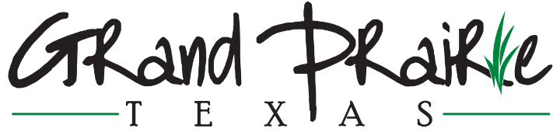

NEWS RELEASE JUNE 1, 2023
Contact: Amy Sprinkles, Communications Director, asprinkles@gptx.org
GRAND PRAIRIE COUNCILMAN JUNIOR EZEONU APPOINTED TO SERVE ON THE NATIONAL LEAGUE OF CITIES’ RACE EQUITY AND LEADERSHIP (REAL) COUNCIL
GRAND PRAIRIE, TX — Junior Ezeonu, Grand Prairie City Councilman At Large, has been appointed to the National League of Cities (NLC) 2023 Race Equity and Leadership (REAL) Council. Ezeonu was elected to a one-year term to develop and guide programs among local elected officials from similar communities. The appointment was announced by NLC President Mayor Victoria Woodards of Tacoma, Washington.
“I am honored to serve,” said Ezeonu. “I look forward to working with my fellow committee members as we develop meaningful programs to affect change and provide guidance for local governments.”
“We are so proud Junior was selected to serve on this meaningful and significant council,” said Grand Prairie Mayor Ron Jensen. “His experience, insight, education, open mind and open heart will be invaluable, as it has been here in Grand Prairie.”
As a member of NLC’s REAL Council, Ezeonu will play a key role among a diverse group of local leaders to encourage collaboration, networking and the development of resources and programs beneficial to communities that share demographics, size or location that can be replicated across the country.
“Our member councils give voice to what’s happening on the ground in our communities,” said NLC President Mayor Victoria Woodards of Tacoma, Washington. “I am proud to have Councilman Ezeonu join NLC's REAL Council. Together with a team of local leaders from around the country, we will work to address the toughest challenges facing our communities and ensure that America’s cities, towns and villages have the resources they need to thrive.”
The leadership of this year’s council will consist of Co-Chairs Councilmember Andrea Barefield, Waco, TX, and Mayor Steve Patterson, Athens, OH; Co-Vice Chairs Councilmember D’Andre Jones, Fayetteville, AR and Mayor Pro-Tem Ty Stober, Vancouver, WA.
For more information on NLC’s member councils, visit: https://www.nlc.org/current-initiatives/member-councils-2/.
###

