Clean Air Action Mails

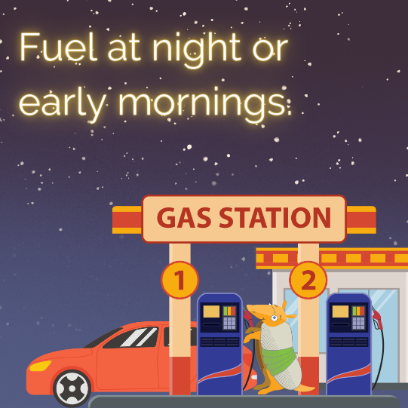
Clean Air Fact of the Day: 80% of lung diseases is caused due to pollution from cars, buses, trucks, and other vehicles.
Clean Air Action Tip: Hot temperatures and gasoline fumes create ground-level ozone. Reduce the effect and refuel your vehicle at night or early morning.
Take the Pledge:
Commit to taking action for cleaner air on June 2, Clean Air Action Day, at https://www.airnorthtexas.org/cleanairactionday (enter your industry name under Company name).

Clean Air Fact of the Day: During heavy traffic jams, pollutants outside can seep into your car, making the air inside your car 10 times more polluted than typical city air.
Clean Air Action Tip: Help reduce traffic jams by carpooling or riding your bike to as many locations as possible.
Take the Pledge:
Commit to taking action for cleaner air on June 2, Clean Air Action Day, at https://www.airnorthtexas.org/cleanairactionday (enter your industry name under Company name).

Clean Air Fact of the Day: Over 40% of the US population is at risk of disease and premature death because of air pollution.
Clean Air Action Tip: Switch to energy efficient light bulbs. The more traditional power that you are using, the more energy you’re wasting thus leading to more polluted air.
Take the Pledge:
Commit to taking action for cleaner air on June 2, Clean Air Action Day, at https://www.airnorthtexas.org/cleanairactionday (enter your industry name under Company name).

Clean Air Fact of the Day: Did you know that lunchtime is the peak hour for ground-level ozone? Your car emits the most pollution during short trips.
Clean Air Action Tip: Instead of driving to a restaurant for lunch this week, stay indoors. Pack a lunch in your reusable bag before you leave in the morning and save gas during lunch.
Take the Pledge:
Commit to taking action for cleaner air on June 2, Clean Air Action Day, at https://www.airnorthtexas.org/cleanairactionday (enter your industry name under Company name).

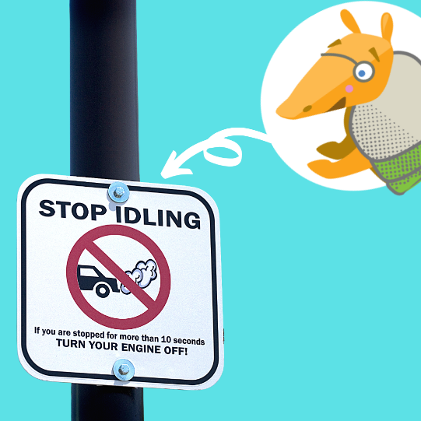
Clean Air Fact of the Day: An idling vehicle releases harmful chemicals, gases, and particle pollution into the air, contributing to ozone pollution. Every gallon of gas burned produces more than 20 pounds of greenhouse gases.
Clean Air Action Tip: To avoid idling, turn your car off when waiting for extended periods of time. If you’re going through a drive-thru, run inside to grab your order instead.
Take the Pledge:
Commit to taking action for cleaner air on June 2, Clean Air Action Day, at https://www.airnorthtexas.org/cleanairactionday (enter your industry name under Company name).

Clean Air Fact of the Day: A typical passenger vehicle emits about 4.6 metric tons of carbon dioxide per year.
Clean Air Action Tip: Stay up to date on regular vehicle maintenance. That includes oil changes, properly inflated tires, fluid checks, etc.
Take the Pledge:
Commit to taking action for cleaner air on June 2, Clean Air Action Day, at https://www.airnorthtexas.org/cleanairactionday (enter your industry name under Company name).

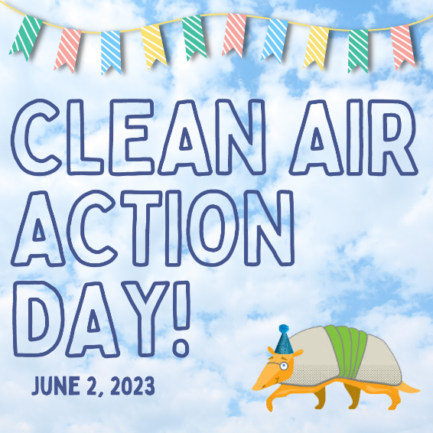
Clean Air Action Day:
Clean Air Action Day is here!
Reading about and knowing air pollution statistics is one thing but doing your part to help is another. Pledge to make one action to help reduce Air pollution today at https://www.airnorthtexas.org/cleanairactionday
Cleaning our air can help save the planet and our own lives if we can help reduce the air pollution stats you’ve been receiving these past few weeks.

